**Tugas 2_Abrar_STIKI Malang_kelompok1**

Hasil form register produk

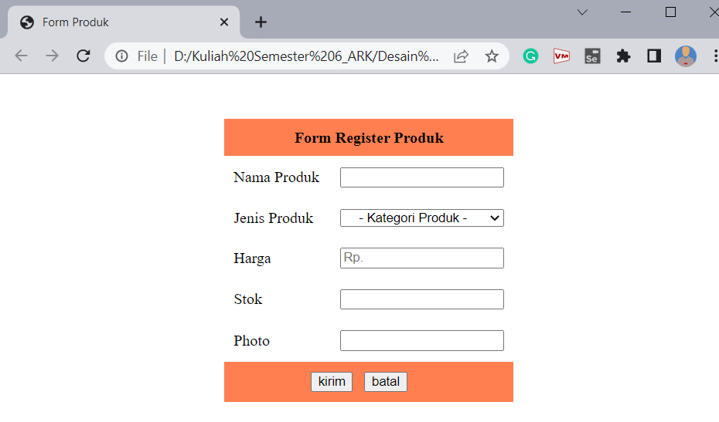

Hasil form register member

